Abstract Art Video Worksheet Name: _______________________________________________

Watch the following video: https://www.youtube.com/watch?v=3kdzGAjG26s

Whilst watching, complete the worksheet. Write what the characteristics of each movement were and some of the artists from that period.

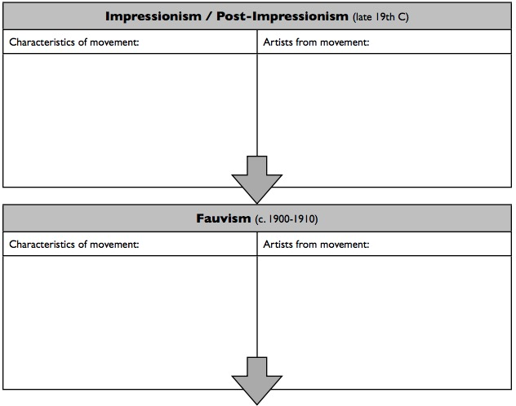
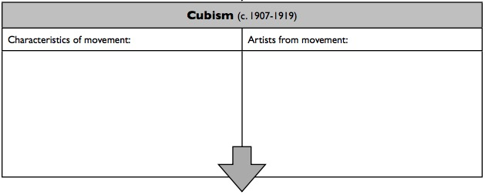

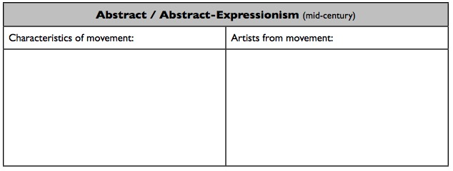

How can we read or understand an abstract painting? What could we look for?

Has your opinion towards abstract art changed? Why or why not?

