Name _________________________________________
Abstractions
Directions: Look at the images in the boxes on the left. Think of how you could abstract those images. In the boxes on the right, please draw abstractly the corresponding image. Color in your finished abstract designs.
Hint: Think simple shapes and colors!
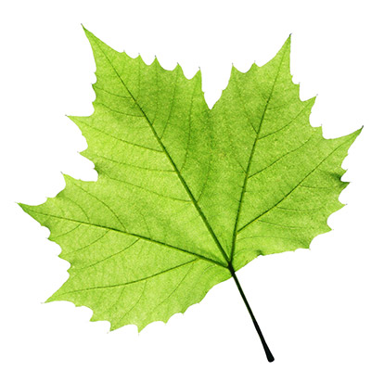
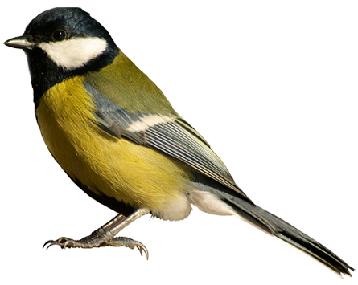
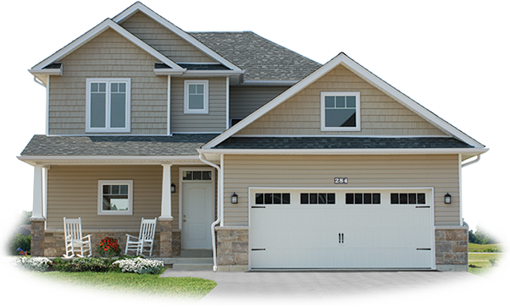

Name_________________________________________
More Abstractions
Directions: Look at the images in the boxes on the left. Think of how you could abstract those images. In the boxes on the right, please draw abstractly the corresponding image. Color in your finished abstract designs.
Hint: Think simple shapes and colors!
