School Year/Semester 2021-2022
Course Name | Painting 1 | Course Code | 50.0321001
School Name | Lakeside High School | Teacher Name | Lisa Slappey
School Phone Number | 678-874-6883 | Teacher Email | lisa_slappey@dekalbschoolsga.org
School Website | http://www.lakesidehs.dekalb.k12.ga.us/ | Teacher Website | https://slappeyart.weebly.com/

Course Description
This course is designed to introduce the basic elements of painting to students with little or no experience. Students will work with acrylic colors and will explore the many ways paint can be handled. Instruction will be given on preparation of materials and specific exercises will be given so that students will explore color, light, texture, transparency/impasto and composition. Exercises become more complex as students work from initial sketches to more developed pieces. While working to attain an understanding of the painting medium the student is challenged to translate concepts into visual images that work. Demonstrations of different techniques will be given. Stress will be given to the proper use of equipment and vocabulary. The course includes a cultural and historical study of master art works of different periods and styles. Students will produce a portfolio of art works that will document and reflect their visual explorations.

Course Prerequisites: Visual Arts and Drawing I

Curriculum Overview
The following academic concepts will be covered. THIS IS ONLY A GUIDE AND IS SUBJECT TO CHANGE.

Unit 1 – Elements and Principles Review | Unit 6 – Intro to Watercolor
Unit 2 – Basic Shapes - Form and Value | Unit 7 – Critiques
Unit 3 – Intro to Oil Painting | Unit 8 – Analysis
Unit 4 – Intro to Acrylic Painting | Unit 9 – Mixed Media
Unit 5 – Art History | Unit 10 – Special Projects

GRADING SYSTEM: The DeKalb County School District believes that the most important assessment of student learning shall be conducted by the teachers as they observe and evaluate students in the context of ongoing classroom instruction. A variety of approaches, methodologies, and resources shall be used to deliver educational services and to maximize each student’s opportunity to succeed. Teachers shall evaluate student progress, report grades that represent the student’s academic achievement, and communicate official academic progress to students and parents in a timely manner through the electronic grading portal. See Board Policy IHA.

GRADING CATEGORIES | *GRADE PROTOCOL
Formative and Diagnostic Assessments – 0%  Assessment Tasks (Skills & Homework) – 25%  Classwork (Guided, Independent, and Group Practice) – 45%  Quizzes, Tests, and Projects – 30% | A 90 – 100 ~P (pass)  B 80 – 89 ~F (fail)  C 71 – 79  D 70  F Below 70

Notes:
*English Learners (ELs) must not receive numerical or letter grades for the core content areas in elementary and middle school during their first year of language development. A grade of CS or CU must be assigned. This rule may be extended beyond the first year with approval from the EL Studies Program. English Learners must receive a grade for ESOL courses.

DISTRICT EXPECTATIONS FOR SUCCESS
STUDENT PROGRESS | Semester progress reports shall be issued four and a half, nine and thirteen and a half weeks into each semester. The progress of students shall be evaluated frequently, and plans shall be generated to remediate deficiencies as they are discovered. Plans shall include appropriate interventions designed to meet the needs of the students. See Board Policy IH.
ACADEMIC INTEGRITY | Students will not engage in an act of academic dishonesty including, but not limited to, cheating, providing false information, falsifying school records, forging signatures, or using an unauthorized computer user ID or password. See the Code of Student Conduct - Student Rights and Responsibilities and Character Development Handbook.
HOMEWORK | Homework assignments should be meaningful and should be an application or adaptation of a classroom experience. Homework is at all times an extension of the teaching/learning experience. It should be considered the possession of the student and should be collected, evaluated and returned to the students. See Board Policy IHB.
MAKE-UP WORK  DUE TO ABSENCES | When a student is absent because of a legal reason as defined by Georgia law or when the absence is apparently beyond the control of the student, the student shall be given an opportunity to earn grade(s) for those days absent. Make-up work must be completed within the designated time allotted. See Board Policy IHEA.
SCHOOL EXPECTATIONS FOR SUCCESS
CLASSROOM EXPECTATIONS | The five most important expectations:  1. Display academic integrity.  2. Be in at your computer and logged on when class begins.  3. Respect yourself and others.  4. Exhibit behavior conducive to the learning process.  5. Follow all Lakeside High School and DeKalb County rules.  Academic Honesty  Honor Guidelines (assignments that do not meet the following requirements will earn 0% for all parties involved, and students will forfeit extra-credit opportunities for the remainder of the semester. Allowing a student to copy your work is as dishonest as copying the work of others):  - All work is to be your own, and not a copy--in part or in whole-- of the work of others and is due completed at the time requested.  - All reports, projects, etc. must be your original work. The research of others may, and should be, included in your work, but it is expected to be properly cited. Give credit where credit is due.  - A test, or quiz is an evaluation of your comprehension alone. There should be no talking, texting, or any form of communication during a test, quiz, or any type of exam. Electronic devices should not be visible at all during tests or quizzes.  - Students should not be in possession of another student’s work at any time. If a student is found with the assignments of another student, the documents will be collected, both students will receive a zero for the assignment.  Examples of academic dishonesty include, but are not limited to:  1) Plagiarism, or the copying of another person’s work without due credit.  - copying someone’s or allowing someone to copy your quiz, test, homework, class work, or lab (etc.) in part or in full  - copying work from the internet, or other resource and claiming it as your own.  - improper citation of references, to claim work as your own.  2) Cheating on tests or quizzes includes (but is not limited to):  - looking at another students’ work for answers.  - having answers written on anything (including desks) or stored electronically during a test or quiz.  - trading test forms with other students prior to/while taking a test.  - unauthorized access and distribution of test/quiz items prior to, during or after testing.  - talking, texting, improper use of technology, or any form of communication during a test, quiz, or any type of assessment.  Late and Missing Assignments  It is the expectation that students submit assignments in a timely manner. All assignments will have a pre-determined deadline. If a student does not complete the assignment by the pre-determined due date, a M will be recorded for the assignment with a score of a zero.  The student will have three opportunities to complete the assignment after the original due date with a grade penalty established by the local school. If there are extenuating circumstances that can be verified, the penalty may not be applied. The teacher must receive the request for the work within one week of the original deadline.
EXTRA HELP | I am available before and after school to provide extra help. Complete the I Need Help! form if there is something with which you need help. I am available via email at lisa_slappey@dekalbschoolsga.org. I can be reached via REMIND and at 404-666-3542.
PARENTS AS PARTNERS | Students are encouraged to write assignments in their agenda books, and it would be a wonderful reinforcement if you would check that they wrote down their assignments. Grades can be accessed by parents through DCSD’s Parent Portal at http://www.dekalb.k12.ga.us/parent-portal  Please feel free to email me if you have any questions or comments about your child’s performance. lisa_slappey@dekalbschoolsga.org

A lab enrichment fee of $40.00 is charged for this course. Fees can be paid on the school webstore or via cash or check made payable to Lakeside High School.

REQUIRED MATERIALS & SUPPLIES

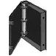 | 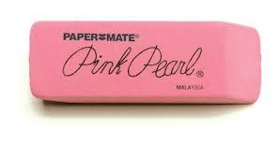  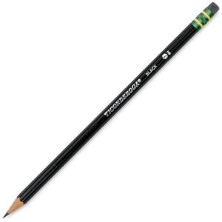 | 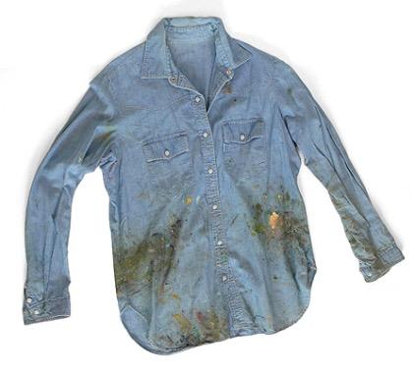 | 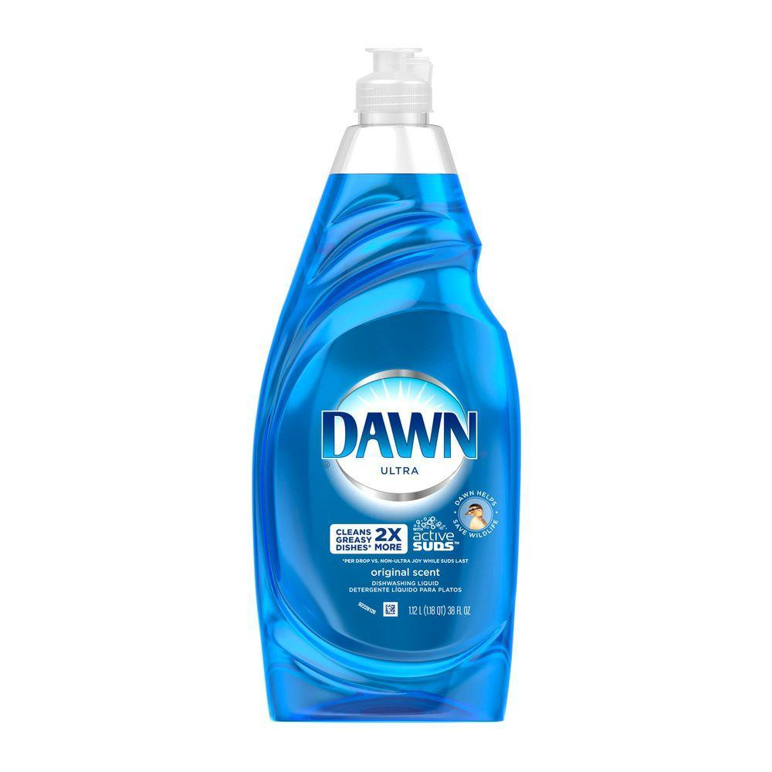 | 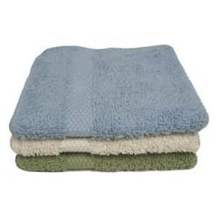 |  | 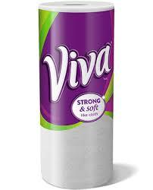
1” (no larger) hard 3 ring binder with notebook paper | #2 pencils  with  erasers | Old shirt or apron | One bottle of Dawn dish soap | Clean washcloth  (old is fine) | Masking tape | One roll of Viva paper towels with no texture  (more would be welcome!)
Extras!!

Aluminum foil, wax paper, plastic wrap, baby wipes, dish soap, paper or Styrofoam plates, sponges, and gallon zip lock bags are always welcome!

PLEASE SIGN BELOW BY CLICKING ON THE LINK.

Painting I Syllabus Parent Signature

